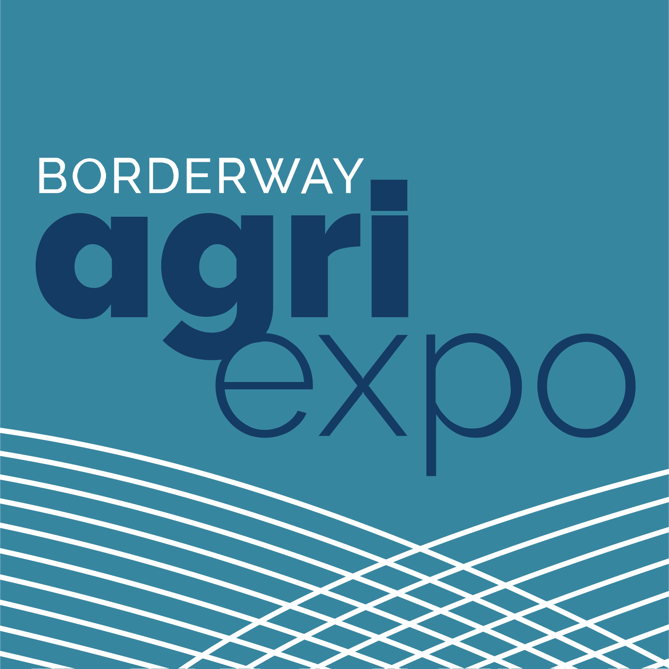
The Gift Ring
Friday 31st October 2025

APPLICATION FORM
EXHIBITOR DETAILS
BUSINESS NAME:

ADDRESS:

POSTCODE:

TEL: MOBILE:

EMAIL:

BRIEF DESCRIPTION OF BUSINESS (max 25 words):

BUSINESS LOGO: Please email a JPEG format of your business logo for maximum promotion.
Email to – carolyn.charlton@borderway.com

All exhibitors are allocated an area of 7ft x 4ft and a table will be provided - the cost is £35.
Payment should be made by BACS to
Account Harrison & Hetherington
Bank Name Virgin Money, 239 Kingstown Road, Kingstown, Carlisle.
Sort Code: 82-70-24
Account Number: 00300044
quoting your H&H account no. in the Reference box

Arrival for set-up – Access to the site will be from 1pm until 6pm on Thursday 30th October
and from 7am until 8.30am on Friday 31st October.
Staffing of stands must be at all times between 8.30am and 4.00pm on Friday 31st October.

Harrison & Hetherington Ltd will not be responsible for any accident, damage or loss however caused, which may occur to any exhibitor or to their sale goods or property brought onto the site. Harrison & Hetherington Ltd will not be responsible for any actions or expenses on account of or in respect of any such damage or injury caused.
All exhibitors must have full third party liability insurance and, if requested, will supply proof of current policy to Harrison & Hetherington Ltd. All exhibitors indemnify Harrison & Hetherington Ltd from any claims made in connection with the exhibitor’s staff, equipment, display, goods or vehicles.

Please accept this application stating our requirements for the event and I/we abide by the conditions applicable for such.

Signed …………………………………………………............ Date ………………........................................
PLEASE RETURN BY EMAIL TO: carolyn.charlton@borderway.com
OR BY POST TO: The Gift Ring, Harrison & Hetherington Ltd, Borderway Mart, Rosehill, Carlisle. CA1 2RS
For further details contact: Carolyn Charlton 01228 406232

